Prince Henry the Navigator
Prince Henry the Navigator (1394-1460) was a Portuguese royal prince, soldier, and patron of explorers. Henry sent many sailing expeditions down Africa's west coast, but did not go on them himself.
These expeditions were sent to create much-needed maps of the West African coast, to defeat the Muslims, to spread Christianity, and to establish trade routes. Prince Henry helped begin the Great Age of Discovery that lasted from the 1400's to the early 1500's.
Early Life: Prince Henry was the third son of King John I of Portugal and his English wife, Philippa of Lancaster. When he was 21, Prince Henry (with his father and brothers) attacked the Moslem port of Ceutha in north Morocco (in Africa, across the Mediterranean Sea). This successful attack in 1415 inspired Prince Henry to explore Africa, most of which was unknown to Europeans. Prince Henry was determined to see Portuguese sailors sail down the west coast of Africa.
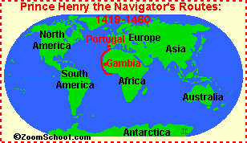
School of Navigation: About 1418, Prince Henry started the first school for oceanic navigation along with an astronomical observatory at Sagres, Portugal. In this school, people were trained in nagivation, map-making, and science, in order to sail down the west of Africa.
Exploring West Africa: At this time, no Europeans had sailed past the treacherous Cape Bojador and returned alive. Cape Bojador is on the coast of Africa just below latitude 27° North (off the western Sahara Desert) and had frequent, violent storms and strong currents. The Europeans called the ocean beyond that point the "Sea of Darkness." Most sailors refused to go there. Prince Henry sent 14 expeditions there over 12 years, trying to go farther than Cape Bojador.

