Name _____________________________________ # __________ Date ___________________

January Math Puzzlers

Three classes at Lakeview School are going on a field trip. The table shows the number of people in each class, including the teacher.  They can choose to use buses, vans, and cars. |  | 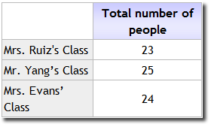

 | 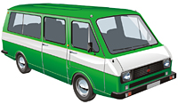
Buses have 20 seats | Vans have 16 seats | Cars have 5 seats
Which three combinations can be used to take all three classes on the field trip?
- 1 bus and 4 vans C. 1 bus and 8 cars
- 3 vans and 11 cars D. 2 buses, 3 vans and 4 cars
E. 1 bus, 1 van, and 6 cars

Ms. Morales has a bag of beads.
- She gives Elena 5 beads.
- She gives Damian 8 more beads than Elena.
- She gives Trish 4 times as many beads as Damian.
Ms. Morales then has 10 beads left in the bag.
Part A:
How many beads did Damian and Trish each receive? Show or explain how you arrived at each answer.

Part B:
How many beads were in Ms. Morales’ bag before any beads were given to students?

