Name __________________________________________ # _________ Date ___________________

February Math Puzzlers

- Baseball stadiums have different numbers of seats. List the stadiums from least to greatest number of seats.
- San Francisco Giants’ Stadium 41, 915
- Washington Nationals’ Stadium 41, 888
- San Diego Padres’ Stadium 42,445

- Compare these statements from two students. Taisei said, “I get the same number when I round all three numbers of seats in these stadiums.” Emma said, “When I round them, I get the same number for two of the stadiums but a different number for the other stadium.” Can Taisei and Emma both be correct? Explain how you know.

- When rounded to the nearest hundred, the number of seats in Aces’ Baseball Stadium is 9,100. What is the greatest number of seats that could be in this stadium? Explain how you know.

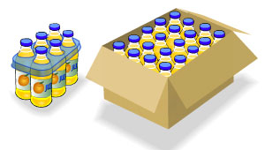
- Aren makes and sells juice drinks. The juice drinks are sold in six-packs and boxes. A six-pack has 6 juice drinks and costs $2. A box has 20 juice drinks and costs $7.

The Friendly Corner Store placed this order:
24 juice drinks packaged in six-packs
200 juice drinks packaged in boxes
Fill in the blanks to complete the order receipt.
